Chapter -16
A Busy month
- Nest is very important for birds.
Explain the need of a nest for a bird.
Ans:
2.Name any six materials that birds use,
to build their nest.
Ans:
3.
Draw the diagram of an egg and label it’s different parts.
Explain the function of each part of an egg.
Ans:
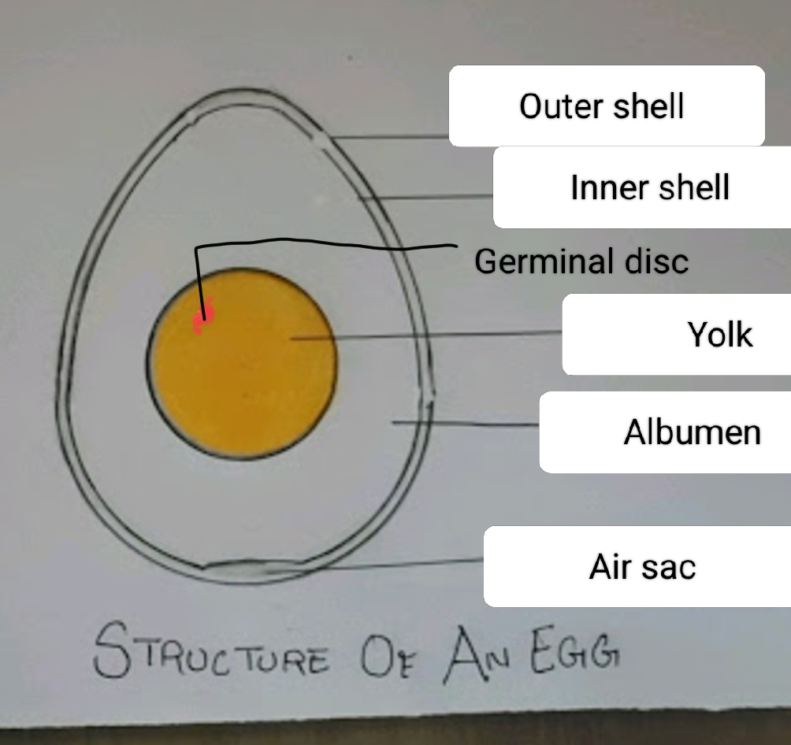

Parts of an egg and their function:
i)Egg shell- It is the protective cover of an egg.
The outer shell is hard whereas the inner shell is
Soft in nature.
ii) Albumen – It is the white jelly like substance
which protects the yolk and contains proteins.
iii)Yolk- It is the yellow part within the albumen
which is the stored food for development of
the embryo .
iv) Germinal disc – It is the embryo -forming part of
the yolk of an egg.

4.Explain hatching in a bird.
Ans: Hatching is the process by which a
young organism( or bird) emergence from an egg.
A parent bird sits on the eggs to keep them warm
and incubate them until they hatch.

5. Birds have toes and claws in their body.
How do they help a bird?
Ans: All the birds have toes and claws on their feet.
These helps to-
a) hold on to things,
b) swim and fly,
c) catch their food and
d) protect themselves from enemies.

6. With the help of suitable diagrams describe
different types of birds feet with their uses
and examples.
Ans:

7. With the help of suitable diagrams describe different
types of birds beak with their uses and examples.
Ans:

8. We have different types of teeth. Each type of teeth
has its own function. Explain them with diagram.
Ans: We have four different types of teeth.
They are- incisors ,canine, premolar and molar.
- Incisors : These are used for cutting and
biting food.
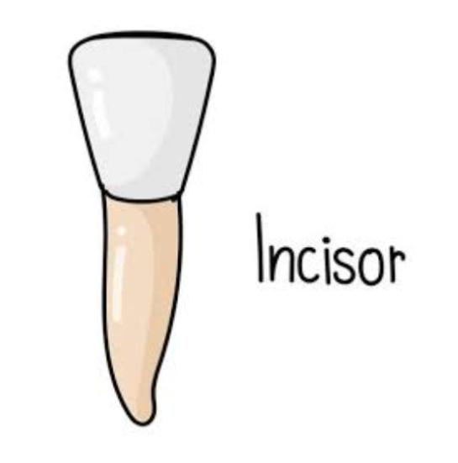
- Canine: These help us to tear food.

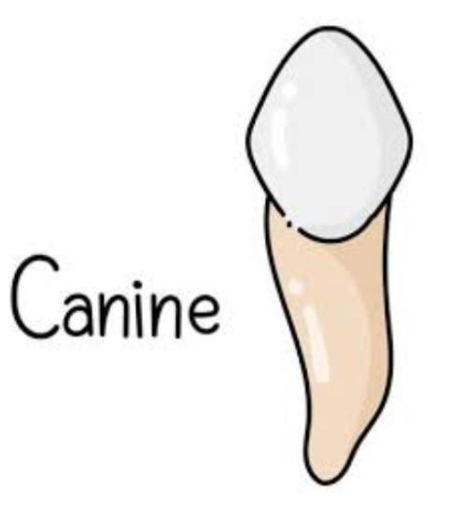
- Premolar: These are used to crack and
Crush the food.
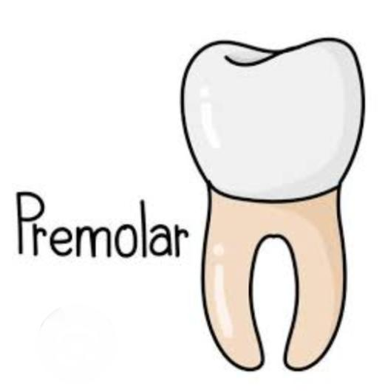

- Molar: These teeth work along with premolar
To crush and grind food. They also work with
Tongue to swallow the food.
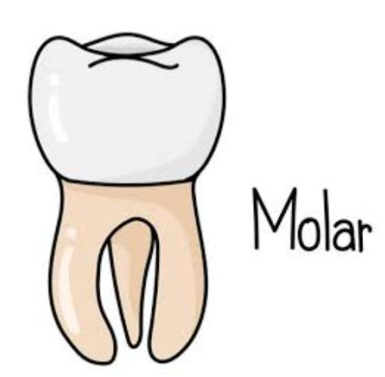

Note-
An adult has 8 incisors, 4 canines, 8 premolars
and 12 molars.

Map pointing
Mark 10 important and famous Bird sanctuaries
In India.

Home work
9. Cows eat grass. Describe how their teeth help
them to eat grass.

10. Snakes do not chew their food instead they
Swallow the food whole. Then mention the
use of their teeth.

11. Describe gnawing in squirrel.

12. How do the cat use their teeth to eat meat?

13. A Coppersmith and Woodpecker are
different from each other in respect to
making nest .How?

